Application Development Orienting

Assignments week 3

Quiz questions, practical assignments and

answers to quiz questions

**Version:** 0.2 **Last updated:** 13 september 2019

Contents

[1 Quiz 3](#_Toc19280865)

[1.1 Question 1 3](#_Toc19280866)

[1.2 Question 2 3](#_Toc19280867)

[1.3 Question 3 3](#_Toc19280868)

[1.4 Question 4 3](#_Toc19280869)

[1.5 Question 5 4](#_Toc19280870)

[1.6 Question 6 4](#_Toc19280871)

[1.7 Question 7 5](#_Toc19280872)

[1.8 Question 8 5](#_Toc19280873)

[2 Practical assignments 6](#_Toc19280874)

[2.1 Programming Assignment 1: Functions and reusability 6](#_Toc19280875)

[2.1.1 Case description 6](#_Toc19280876)

[2.1.2 Provided material 6](#_Toc19280877)

[2.1.3 Screenshots 7](#_Toc19280878)

[2.1.4 Additional features 7](#_Toc19280879)

[2.2 Programming Assignment 2: Mathematics 8](#_Toc19280880)

[2.2.1 Case description 8](#_Toc19280881)

[2.2.2 Provided material 8](#_Toc19280882)

[2.2.3 Screenshots 8](#_Toc19280883)

[2.2.4 Additional features 9](#_Toc19280884)

[2.3 Programming Assignment 3: Car application 10](#_Toc19280885)

[2.3.1 Case description 10](#_Toc19280886)

[2.3.2 User interaction 10](#_Toc19280887)

[2.3.3 Screenshots 10](#_Toc19280888)

[2.3.4 Provided material 10](#_Toc19280889)

[2.3.5 Additional features (optional) 11](#_Toc19280890)

[3 Quiz answers 13](#_Toc19280891)

# Quiz

Difficulty: C:\Users\874156\Desktop\flatastic-icons-part-1-by-custom-icon-design\png\16x16\star-4_5.png. Estimated time: 30 minutes.

Answers to the quiz-questions can be found in the last section of this chapter.

## Question 1

In a solution, we have the following function definition:

public double Add(double x = 2, double y)

{

return x + y;

}

Can you spot the error and correct it?

## Question 2

Another definition in for example the same solution is as follows:

public void Multiply(double x, double y)

{

return x \* y;

}

As before, what is the error in this code snippet?

## Question 3

We get back to our Multiply function from earlier, this function is now correctly defined and a user tries to make a call to it as displayed below:

Multiply(1, 2, 3);

Will this function call execute correctly?

## Question 4

We have several simple function definitions as defined below:

public int AddOne(int x)

{

return x + 1;

}

public int Quadruple(int x)

{

return x \* 4;

}

Your user makes a call as shown below, assume that the call executes correctly and does return a value, what is the value returned?

Quadruple(AddOne(AddOne(2)));

## Question 5

The following function is defined:

public int ReturnMyNumber(int x, int y, int z)

{

if (Convert.ToBoolean(x))

{

return y;

}

else

{

return z;

}

}

Does the code execute without errors, and if it does, what do you think it returns and why so?

ReturnMyNumber(100, 4, -1);

## Question 6

The same function as before is defined but now it is slightly changed and another function is defined that makes a call to the other function, see below:

public int ReturnMyNumber(bool x, int y, int z)

{

if (x)

{

return y;

}

else

{

return z;

}

}

public int ReturnOneOfTwo(int x, int y)

{

return ReturnMyNumber(x == y, 3\*y, x);

}

Does the code execute without errors, and if it does, what do you think the return values are and why so?

ReturnOneOfTwo(4, -1);

ReturnOneOfTwo(5, 5);

## Question 7

What are the values of the variable sum and n after running this piece of code:

int sum = 0;

int n = 45;

for (int counter=0; counter<7; counter++)

{

sum = sum + counter;

n = 2 \* counter;

}

## Question 8

What are the values of the variable result and n after running this piece of code:

int result = 10;

int n = 1;

for (int i=2; i<11; i+=3)

{

result = result + n;

n = n \* 10;

}

# Practical assignments

## Programming Assignment 1: Functions and reusability

Difficulty: C:\Users\874156\Desktop\flatastic-icons-part-1-by-custom-icon-design\png\16x16\star-2_5.png . Estimated time: 75 minutes.

The assignment covers the following learning goals:

* Understanding code reuse and writing basic functions.

You’re going to implement your first few functions. As practice, these functions will be very basic but they will require you to apply the concepts you learned in previous weeks too!

### Case description

In this assignment you are going to create a simplified version of an automated teller machine. The ATM allows you to select different amounts of Euros to either withdrawal or, for this assignment also deposit. It is up to you, the student to implement several pieces of functionality by creating functions.

### Provided material

What you are up to is designing the screen of the ATM, make it look somewhat like the screenshot. You are highly encouraged to also add your own creative ideas to the design and functionality. Add controls to ATM Form such as shown in Figure 1: Possible GUI (see screenshot). After you’ve done that, make sure to add a variable into the Form that will represent your bank balance, so private double bankBalance.

Now for functionality, implement the function body of the private double GetSelectedAmount() function. The purpose of this function is to return the appropriate amount based on what the user selected on the screen.

*If you’re done and found that already repetitive, be glad that you made a function such that you can now use that same piece of code in any other place within your application as needed.*

*The function also allows you to maintain your code a lot easier, you don’t have to jump around and fix it in all the places you copy pasted your code. The same holds in case you wanted to extend your ATM application with for example another amount to withdrawal or deposit. You only have to add another if else in one place with a reduced chance of making a mistake.*

Now to make the application function, add the required code to withdraw and deposit money into the bank via the ATM. Make it so that your bank balance is also updated and displayed on the ATM screen! When updating the bank balance on the screen, think of what you learned and try to avoid code repetition by creating a function to do this.

You’re almost done, if you select a high amount of money and press withdrawal, your balance might end up in the reds. Try to avoid this by creating a function that might have a function header like private bool SetBankBalance(). The goal of this function is to change the bank balance if the amount is not negative and if the withdrawal is successful, return true.

Try to compile/run your code to determine if there are any errors. If there aren’t make sure to test if your functionality works properly.

### Screenshots

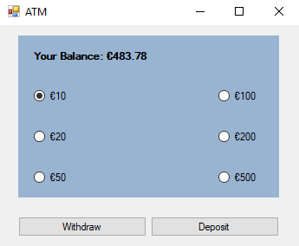

Figure 1: Possible GUI

### Additional features

Extend your application such that the user can also enter an amount of choice to withdraw. If you want to make it even more complex, try to make it so that only multiples of 10 can be withdrawn!

## Programming Assignment 2: Mathematics

Difficulty: C:\Users\874156\Desktop\flatastic-icons-part-1-by-custom-icon-design\png\16x16\star-2_5.png. Estimated time: 60 minutes.

The assignment covers the following learning goals:

* Understanding and applying the basic concepts of functions.

### Case description

You’re going to write several simple functions that are math based and allow you to solve different problems.

### Provided material

Start a new Windows Form Application project and add 3 or 4 TextBox objects to it, 3 will be used for number input and alternatively 1 can be used for displaying the result, but you can also do this in a label if you want. For the rest, add a button to the form and add about 7 radio buttons that you will need to select specific functions you will define later on.

The set of functions for this assignment and their goal are listed below:

**Make sure to use int types for the inputs and returns for numerical functions.**

* Square – returns a2
* Cube – returns a3
* Fourth Power – returns a4
* Double – returns a \* 2
* Absolute Value – should return |a| (a if a is negative or positive)
* Is Odd – displays true if a is odd
* Is Even – displays true if a is even
* Minimum of 3 Numbers – should return the smallest number of a, b, c
* Maximum of 3 Numbers – should return the largest number of a, b, c

If you require inspiration on how the application could look like, please view the screenshot at the end of this assignment.

### Screenshots

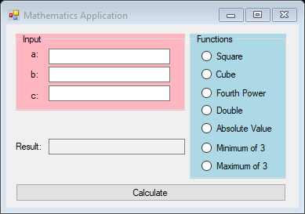

Figure 2: Possible GUI

### Additional features

Additionally, you could add Boolean functions in a new group GroupBox. For example, you could add functions to test whether number a is even or odd. You can create for example a Boolean function that will test if the distance between numbers a and b is larger than the distance between a and c. And as always you are encouraged to add and experiment with functionality yourself!

*The additional functionality above as well as some of the functions you defined earlier can perfectly make reuse of other defined functions. For example, did you write the odd and even functions out as two entirely different bodies or did you express one as the opposite of the other? Think about it, if a number is not odd, it is even. Likewise, if a number is not even, it is odd.*

## Programming Assignment 3: Car application

Difficulty: C:\Users\874156\Desktop\flatastic-icons-part-1-by-custom-icon-design\png\16x16\star-2_5.png. Estimated time: 60 minutes.

The assignment covers the following learning goals:

* Understanding and applying simple functions to represent the behavior of a car.

### Case description

We want to implement a simulation for a car accelerating and breaking. A car has a current speed. This speed can become higher (by accelerating) or smaller (by using the brakes). A car has a maximum speed which cannot be exceeded.

### User interaction

The application should display some information about a car. There are two buttons to directly modify the speed of a car and one that is going to represent a silly auto pilot. Clicking Accelerate or Brake should result in the current speed of the car increasing or decreasing respectively. The information should be updated and displayed in for example a label.

### Screenshots

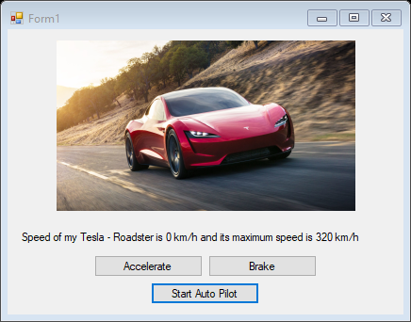

### Provided material

Start a new solution and add two Button objects, a PictureBox object and a Label object to the form.

Add some variables to the form to store the car its brand (a string), its model (a string), its current speed (an integer), its maximum speed (an integer), the amount to accelerate per event (an integer) and similarly the amount to brake per event (an integer).

You will require three functions in total to make it work.

Add a function to the form

public void UpdateCarInfo()

This function is responsible for updating the label’s information with the car’s current state, as pictured in the label in the screenshot above.

Add two functions, one for accelerating and one for braking:

public void Accelerate()

public void Brake()

In the real world you can speed up or slow down with a variable acceleration. In this assignment, we assume speeding up is always by increasing the current speed with x km/h. Slowing down is always by decreasing the current speed with x km/h. Implement these two functions in the form.

Now let’s work on the Form1. Add or position the controls in your Form1 to make it look like the screenshot above.

At start-up of your app, you should assign values to the variables you defined earlier. At least make sure all the required variables have a value when the application is started!

Run your app to see if it runs. If so, we do not see anything on the screen yet and clicking the buttons has no effect. But it runs, so there are no syntax errors in it.

Now, show the information of your car in the label by calling in the Form’s constructor:

UpdateCarInfo();

Run your app. Note that the information is now displayed on your screen.

Now work on implementing the Accelerate and Brake button and display the proper information after you pressed it.

Question: if you accelerate several times, is it possible that the speed of the car exceeds the maximum speed? If that is the case, adjust your implementation for your method public void Accelerate() in such a way, that the current speed is never bigger than the maximum speed.

Same question for using the brakes: can the speed become negative?

### Additional features (optional)

Implement the Start Auto Pilot function for your car.

For this to work in a very simple manner we will add a Random object to our form. Add a variable as private Random rng; and in the constructor, rng = new Random ();

Now go back to your Form Design, Toolbox and add a Timer object into your form. You will see this below your Form.

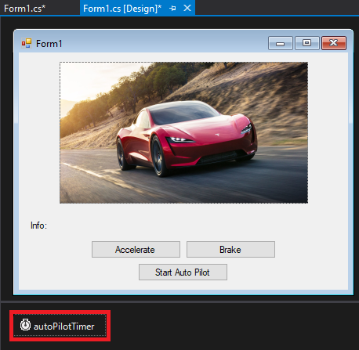

Right click on it and select Properties. In the Properties Window, give the Timer a suitable name and change the interval to for example 2000, this is equivalent to 2000 milliseconds which in turn is equal to 2 seconds.

Now return to the code of your Form and implement the code for the Auto Pilot Button. In the body you want to create a conditional statement that will check if the text of the Button contains start, and if it does, you want to start the Timer by making a call to myTimerObject.Start(); and then update the Auto Pilot Button text to include the word stop instead of start. Instead of checking the Button text you can also introduce a Boolean variable to check the status of the Timer.

Apply the opposite logic in the else clause by calling myTimerObject.Stop(); and update the button’s text to contain start again instead of stop.

Now go back to your form and double click on the Timer object that was outlined with red in the screenshot. Inside the body of the Timer you will create an integer variable representing a choice, and assign the following to it: rng.Next(0, 2); this will return a random integer with a value 0 or 1.

Now add a conditional statement that checks whether the integer is 0 or 1 and make your own decision if you want the car to accelerate or brake. Also add accelerate or brake to the else clause of your conditional statement.

Finally add a call to the UpdateCarInfo() at the end of the function body such that every time the timer ticks, the label is also updated accordingly.

If you implemented everything correctly, pressing the Start Auto Pilot Button should now result in the text of the Auto Pilot Button changing, and the car randomly accelerating or braking every 2 seconds.

# Quiz answers

|  |  |
| --- | --- |
| Question | Answer |
| 1 | Error, the optional parameter must appear after all required parameters. (double y, double x = 2) |
| 2 | Error, the return type is of type void, the function tries to return an actual value in the function body which is not allowed. It is however allowed to break out the function earlier by using return immediately followed by a semi-colon. |
| 3 | Error, the function was defined to accept 2 input parameters and not 3. |
| 4 | The value returned = 16.  The inner most function has to be evaluated first for the encapsulating function to evaluate etc.   * Quadruple(AddOne(2 + 1)); * Quadruple(2 + 1 + 1); * As the value 4 is now assigned to the parameter x the function returns 4 \* 4; |
| 5 | Yes it executes without errors and returns 4.  The value 100 is converted to a Boolean which evaluates to true.  The test C# executes is equivalent to: number != 0 (tests if the number is not equivalent to the number that false represents). |
| 6 | Yes it executes without errors, it returns the value 4.  It passes as arguments to ReturnMyNumber(false, -1, 4) binding -1 to y and 4 to z, since x == false, the else clause is entered and z is returned, thus the value 4. *Read and analyze carefully!*  The second statement returns the value 15. |
| 7 | sum=21 and n=12 |
| 8 | result=121 and n=1000 |